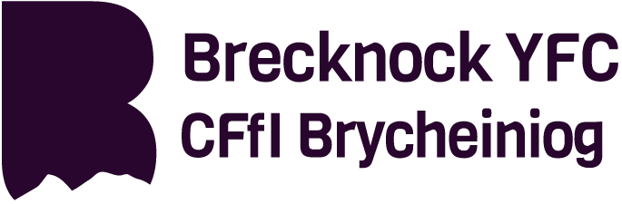
PRINCE’S COUNTRYSIDE FUND  BRECKNOCK YFC TRAINING EXPRESSION OF INTEREST FORM – ROUND 8 | Brecknock YFC Office  Hay & Brecon Farmers  Ffrwdgrech Industrial Estate  Brecon, Powys, LD3 8LA  Tel: 01874 624 889  Email:brecknockyfc@gmail.com
Brecknock YFC have been successful in securing funding to support training in the Agricultural sector to further a rural based career. The funding will be available until January 2021. There will be two windows of opportunity per year to access the fund. Round 8 is now open and will close on Friday 11th February 2022. The funding is easy to access for active YFC Members and associate members, aged up to 30 years. All applicants must be a current, participating YFC or associate member of a club within Brecknock and have paid their club membership for the year of applying and undertaking the training. To access the fund, you will need to complete an expression of interest form. All applicants will be notified 1 month after the closing date if they have been successful. If your application is approved you will be able to reclaim 80% of the net training and test costs if you are eligible to claim back VAT, or 80% of the total cost if you are not eligible to claim VAT. You can claim up to a maximum of £250. There will also be up to 3 workshops per year organised which can be accessed on top of the training bursary of £250. The workshops will be delivered depending on demand and applicants will be notified of places available and types of workshops once all expressions of interest forms have been assessed after the closing date.
Please note all correspondence regarding your application will be made by email, therefore it is important to check your email regularly and respond promptly.
The fund will support training that will; improve your employability, increase, or improve your skill set, improve your safety or allow you to undertake extra responsibility in your current job.
FULL NAME: |  | ADDRESS:
HOME TELEPHONE NUMBER: |  | POSTCODE
MOBILE TELEPHONE NUMBER: |  | EMAIL ADDRESS:  (Please note all correspondence will be completed by email.)
DATE OF BIRTH: |  | CURRENT MEMBERSHIP NUMBER:
CLUB YOU ARE A MEMBER OF: |  | (You must be a member or associate member of a club in Brecknock ONLY)
Please list the training you wish to undertake and use the funding for. As this is an expression of interest you can list more than one course/workshop.

If known, please list any specified training provider you will be using for the courses listed above.

Are you eligible to claim the VAT? | YES / NO | Have you received funding from the Prince’s Countryside Fund before? | YES / NO
Net Cost of training to include test costs where applicable plus VAT if applicable | NET COST: £  VAT: £ | Have you applied to any other funds for this training? For example, Farming Connect. | YES / NO
If YES please give details of the funding provider and how much funding.
What is the reason for undertaking this course? (Applications will be assessed for suitability against the following key points; Will this course make you more employable, improve your skill set, improve safety or allow you to undertake extra responsibility in your rurally based career.
Signed: |  | Printed Name:  Date
TERMS & CONDITIONS
- This Form must be completed in full, any boxes not relevant complete with N/A. Please return your completed form to Brecknock YFC Office, Hay & Brecon Farmers, Ffrwdgrech Industrial Estate, Brecon, Powys, LD3 8LA or email: brecknockyfc@gmail.com
- Funding available to participating members and associate members aged up to 30 years of clubs within Brecknock YFC only.
- Applicants must have paid their membership in the year of applying and completing the training
- Applicants will be notified 1 month from the closing date of the expression of interest window if they have been successful
- All correspondence will be conducted by email
- Members are responsible for organizing their own individual training/test.
- If successful further information may be requested such as proof of completion of a training course - certificate/evaluation form and receipted copy of an invoice for training completed.
- Timescale – Members are required to book/complete their course within 6 months of their application approval date.
- Closing date – Friday 11th February 2022

Charity Commission No. / Rhif y Comisiwn Elusennol 1169501

