As charity trustee of the club
(the YFC Club Management Committee) …

You collectively, along with all the other trustees, are ultimately responsible and accountable for the management (governance) of the club and all its activities, ensuring it’s legally run in line with the club’s constitution, the law and is a safe place for members.
The charity trustees of a YFC are known as the management committee (the executive committee or Board at a county federation level). They are appointed from the club’s membership and serve in the post for a year, and can be re-elected. The charity trustees of the club are normally three of the following positions - the chair, vice-chair, secretary, treasurer and a leader, all of whom should be over 18 years of age of over.
Where club officers are under 18, then charity trustees will be at least three people drawn from the leaders and the advisory committee.
The responsibilities of charity trustees should be read and understood before accepting a nomination into charity trustee role. As a trustee of the club (as a charity) you should expect safe recruitment processes to be applied to your nomination to this role. This will include:
- completing a Position of Trust form
- a self-declaration
- a request to supply the names and contact details of two people who can be approached for independent references (one may be from the YFC community and another independent of the YFC) and
- that a DBS check at enhanced level with barred lists will be carried out.

If you fail to supply the names of two referees and information required for a DBS check to be made within the first four weeks, you should consider yourself to be ‘stepped down’ or ‘removed’ from the role. In this instance the club can hold a new election for the position.

Information taken from The Essential Trustee, published by the Charity Commission. The Charity Commission encourages all charity trustees to read the guidance and refer to it whilst undertaking charitable duties and decision making.
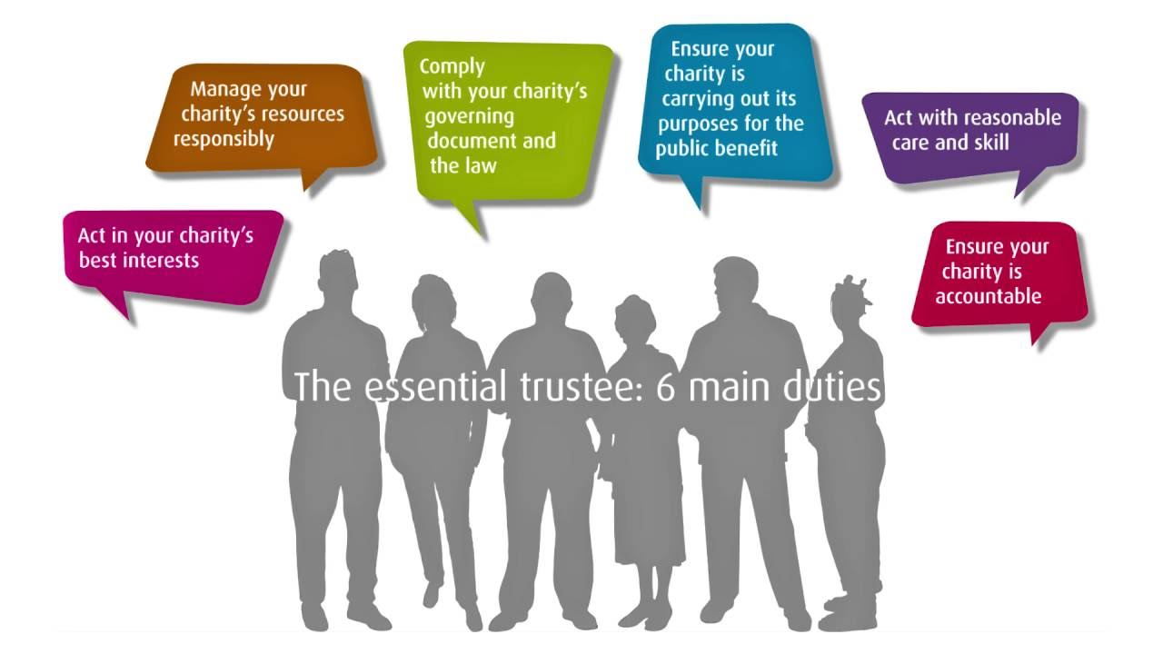
Source: The Essential Trustee (CC3), The Charity Commission

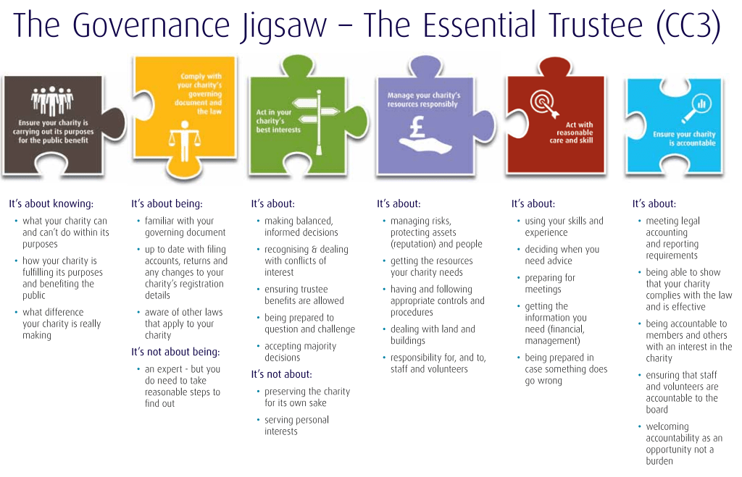Source: The Essential Trustee (CC3), The Charity Commission

Responsibilities of the charity trustees include:
- Accepting ultimate responsibility for directing the affairs of your club, ensuring that it’s solvent, well run, and delivering its charitable objectives while upholding the reputation of a youth organisation.
- Understanding and ensuring that your club complies with its governing documents (club’s constitution), charity law, employment law, safeguarding law and any other relevant legislation.
- Ensuring that your club pursues its objectives as defined in the constitution.
- Making sure your club uses its resources solely to meet the objectives set out in its constitution and that funds are used only for the purpose for which they were given.
- Ensuring your club accounts for its activities to its funders, Charity Commissioners, members and any others as required.
- Contributing to your management/executive/club committee’s role by providing strategic direction to your club, understanding policy, defining goals and targets and evaluating events and activities.
- Safeguarding your club’s good name and the ethos of the organisation as well as acting in the best interests of its members at all times.
- Safeguard the members of your club and those that hold club office or volunteer to support the club. This is done through training, safe recruitment processes and record keeping.
- Ensuring the effective and efficient administration and financial stability of your club.
- Appointing club officers as appropriate, using their skills and seeking training to help them develop key skills where necessary.
- Working effectively with other members of the executive committee.
- Attending meetings and reading papers in advance of meetings.
- Undertaking other tasks as required.
- Keeping informed about the club’s activities.
- Communicating with county office or NFYFC when unsure about a governance issue.
- Further information about charity governance can be found on the Charity Commission website.

Top tips for your role
Good charity trustees are essential to the smooth running of a YFC. Here are a few things to try.

Be positive
Make the most of your time as trustee. There's lots to learn with challenges and successes along the way.

Be open
It’s in everyone’s best interests to be open and inclusive. Make as much information available as possible.

In the know
Know what you're taking on. Ask questions, read reports and understand what is involved right from the start.

Advisors
When you're unsure about something seek the advice from specialist sources.

Decisions
Don't make decisions on anything you don't understand. Ask questions until you do.

Version | Date | Author | Comments & status
1.0 | 29.06.2021 | NFYFC | Final document - for publication

