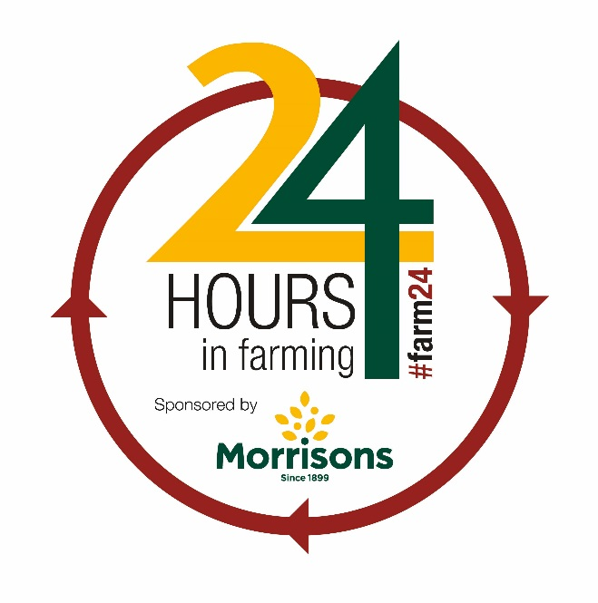

PRESS RELEASE
July 16, 2018
Let’s shout about farming

The agricultural industry’s biggest online farming event is back for the fourth year running. 24 Hours in Farming returns on August 9, 2018, beginning at 5am and running until 5am, on August 10.
Once again sponsored by Morrisons, the event invites farmers and those working within the wider agricultural industry to take to social media platforms to showcase the work they do in a normal day. The aim is to demonstrate to consumers just how much passion and commitment goes into producing the food they eat and maintaining the great British countryside.
The event has now built up a huge following, last year achieving a Twitter reach of more than 100 million, trending in the top five all day and attracting a number of high profile supporters.
Anyone can take part by posting about the work they are doing, sharing photos and videos from Facebook, Twitter, Instagram and SnapChat accounts and simply using the hashtag #Farm24. This year for the first time we are also urging consumers to get involved by posting photos of their meals incorporating British produce and including the #Farm24 hashtag.
Farmers Guardian Editor Ben Briggs says: “UK agriculture has a fantastic story to tell and 24 Hours in Farming allows everyone to shout about the industry and why they are so proud to work within it. It has become the go-to event within agriculture's social media calendar and we want as many people as possible to be involved again in 2018.”
Andrew Thornber, Morrisons Maufacturing Managing Director, says: “Morrisons is pleased to sponsor 24 Hours in Farming. We understand it is important for British farmers and it is really important for Morrisons because we rely on British farming's success.
“If our customers are going to buy more British food and support the British countryside, it’s really important to show them what farmers do everyday, their high standards, and efforts to feed our communities and families.”
For more information about 24 Hours in Farming, visit: www.fginsight.com/farm24

Ends

